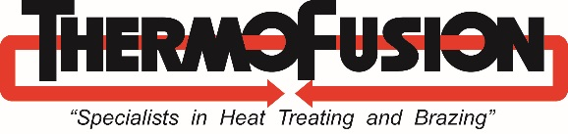

**ThermoFusion’s History:**

ThermoFusion is a family owned and operated heat treating and brazing business that started in the San Francisco Bay Area in 1969. They moved to their current location in 1972, started two additional heat treating and brazing shops which they sold in the early 2000’s, and invested in people and equipment to support their growing customer base. Like many businesses, they downsized significantly in 2008. Slow steady growth since then has built ThermoFusion back up to three shifts and at least 5 day-a-week operations. In 2016, as part of its growth, ThermoFusion acquired another local heat treat business.

**Quality Programs:** ThermoFusion is committed to customer satisfaction through excellence in heat treating and brazing services. ThermoFusion and its employees take pride in the quality of their work and are dedicated to improving. The Company has taken many steps to establish a comprehensive, robust, continually improving quality program.

* Gained ISO 9001 Certification in 2000
* Attained AS9100 Certification in 2014
* Recently expanded their Aerospace capabilities by achieving NADCAP Accreditation in July 2019
* Northrop Grumman SPARS that ThermoFusion maintains are:

C3825 – carbonitride steel

C3783 – carbonitride steel

C3618 – carbonitride steel

A3896 – malcomizing (nitriding) stainless steel

  A2016 – nitriding steel and stainless steel

  A2011 – general heat treatment of steel, aluminum and copper

* Continually participates in MTI Heat Treat Academy and enrolls all employees in online academy courses
* Strong proponents of the Metal Treating Institute’s YES Management Training Program, ThermoFusion employs 2 graduates of the program, a third will graduate in 2019, and a fourth young executive is registered for the 2020 session
* ThermoFusion is currently implementing a paperless shop traveler system via Throughput BlueStreak with integrated preventative maintenance, NCRs and CAPAs.

**Pollution/Hazardous Waste Control:** ThermoFusion continually works to minimize possible pollution or hazardous waste, and has made (and continues to make) significant investment to help prevent the depletion of natural resources and reduce the carbon footprint of the metals industry.

Every year, ThermoFusion participates in a Demand Response Program to reduce annual energy consumption and curtail usage during peak use times. In 2012, ThermoFusion partnered with their utility company, Pacific Gas & Electric, in a project to upgrade the burners on their IQ furnaces to make them more energy efficient.

When purchasing new equipment, ThermoFusion often opts for environmentally friendly alternatives. A few examples of their eco-conscious choices include:

* A wash tank that cleans parts without the use of ecologically harmful caustic chemicals
* A wash tank attachment for the gravity separation of water and oil to reclaim the used oil for recycling
* Closed loop furnace cooling systems which reduce water consumption
* Installation of low flow toilets also to reduce water consumption

ThermoFusion quickly achieved sample frequency reduction status in the State Storm Water Compliance Program due to facility storm sample averages testing below Numeric Action Levels for pollutants. They customarily recycle universal wastes including printer toner, batteries and fluorescent bulbs, and are working toward a paperless production software system which will not only improve efficiency but also minimize paper waste.

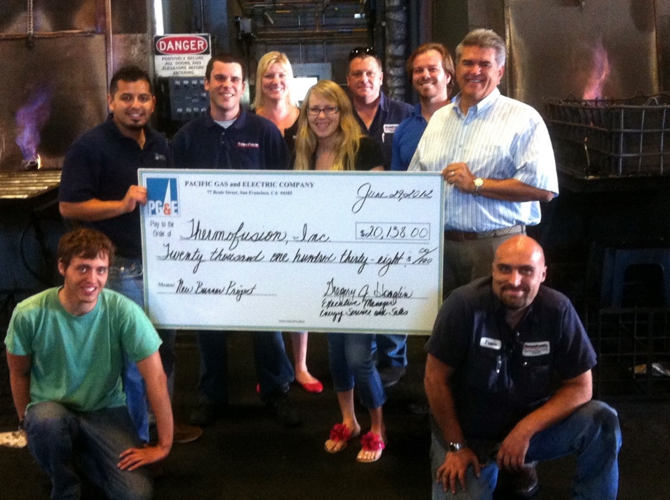

The ThermoFusion Team including President Glen Ottinger (second from upper right) & CEO Dave Buttner Sr. (far upper right) pose proudly with their energy rebate check following the completion of the energy efficient IQ furnace burner upgrade.

**Community Involvement/Leadership:** ThermoFusion’s leadership is committed to more than just profits; it is committed to their community. Their philosophy is that investing in the local community is of utmost importance because if they do not invest in their community, they cannot continue to exist in it.

ThermoFusion conducts regular San Jose State University Engineering Student Tours for the Metals & Alloys Class (MatE 154). In 2011, they launched their Summer Internship Program providing practical experience for engineering students to better understand theoretical lessons. Interns learn and practice pre and post heat treat material testing, incoming and outgoing inspection, furnace calibration and operational adherence to AMS 2759/D.

ThermoFusion provides frequent scholarship grants to outgoing student interns.

Each year, the company contributes pro-bono work for the Cal Poly San Luis Obispo Baja Society of Automotive Engineers Racing Team and the UC Berkeley SAE Formula Racing Team.

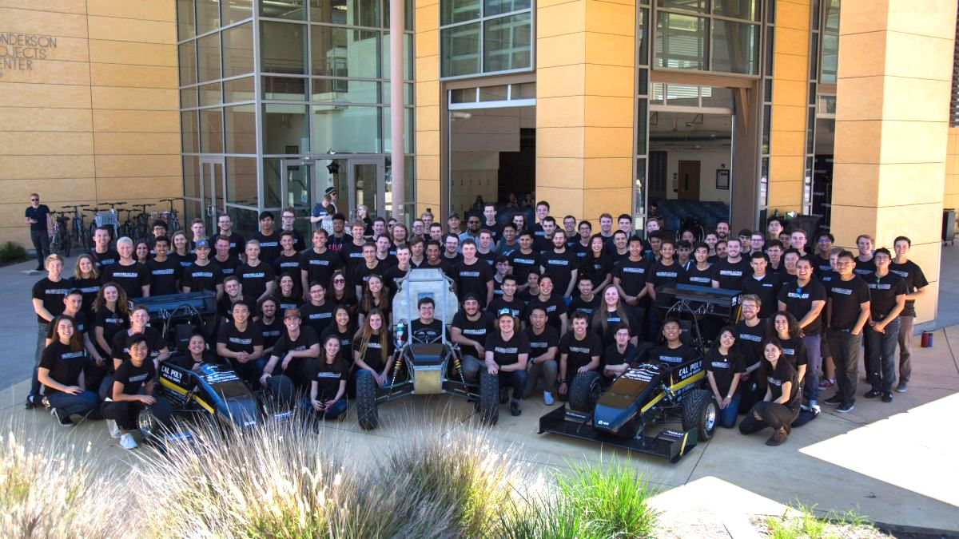

The 2019 Cal Poly San Luis Obispo Baja Society of Automotive Engineers Racing Team.

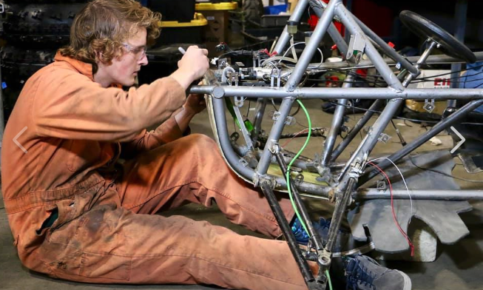

Former ThermoFusion Engineering Intern Cameron Atwood works on the frame

for the Cal Poly Baja SAE racecar.

At local Elementary School Career Days ThermoFusion executives give presentations promoting heat treating and the metals industry.

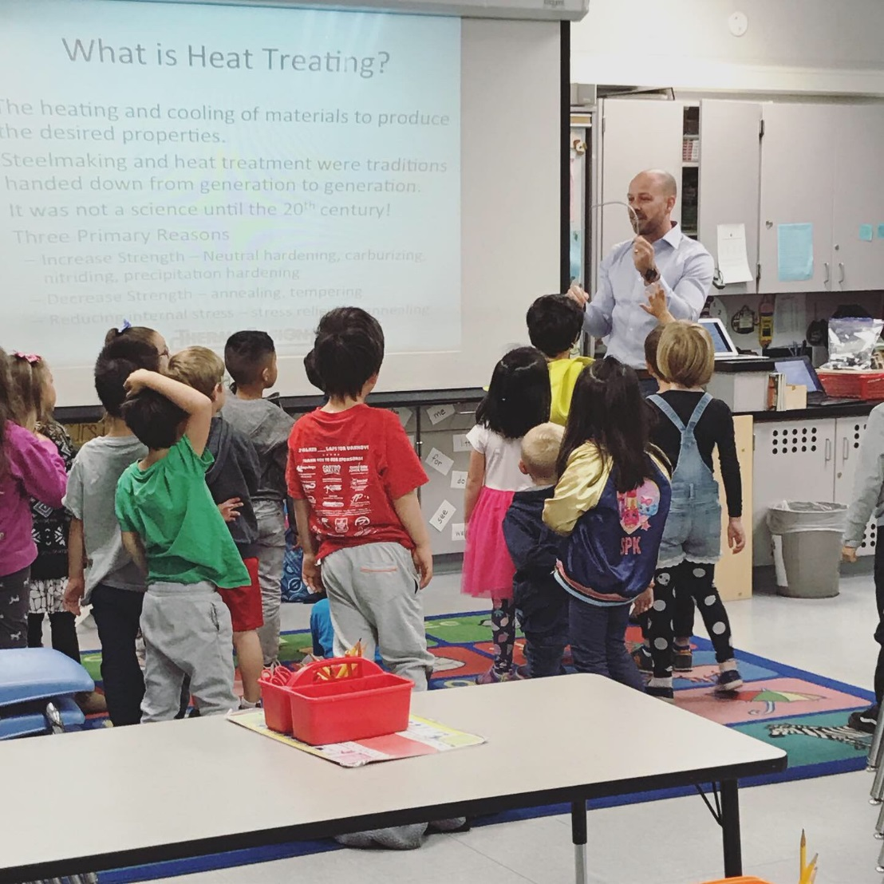

ThermoFusion President Glen Ottinger teaches kindergartners about the Metals Industry and related careers

at an Elementary School Career Day.

The company makes annual donations to Odyssey of the Mind, a competition for grade schoolers that encourages learning through creative problem solving and team building.

ThermoFusion’s hallways are adorned with the many thank you letters from children at local elementary schools who have benefitted from biweekly fruit donations & regular monetary donations to their lunch programs and classrooms.

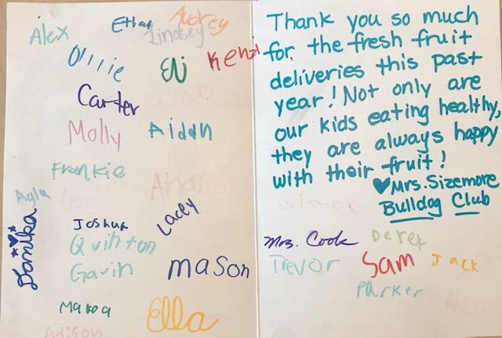

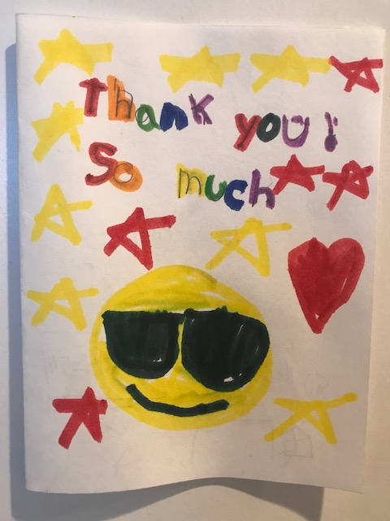

Sorry but you won’t receive chocolates and tchotchkes from ThermoFusion at Christmastime. Their gift to their customers every year is a donation to UCSF Benioff Children's Hospital Oakland.

Most importantly, ThermoFusion, Inc maintains a culture full of fun, festivities, and familial belonging amongst their 35 employees. Annual Thermy Awards Parties are an employee favorite as they acknowledge employees, vendors, and guests for their trivial quirks, capabilities, and mishaps in a celebration of silliness.

Throughout their 50 year history, ThermoFusion has made a positive impact on their community and the metals industry, and they plan to continue for the next 50 years!